ECE 441 Fall 2021

WEEK #3 GROUP MEETING LOG

Lab Session: 2

Group Number: 2

Instructor: Dr. Jafar Saniie

Due Date: 02-02-2022

Acknowledgment: I acknowledge all of the work (including figures and codes) belongs to me and/or persons who are referenced.

Member 1: Alan Palayil

Member 2: Fabian Garcia

Member 3: Gabriel Gutierrez

[Smart Mirror - *Through the Speculum*]

**Project Goal:**

* App integration (Using platforms like IFTT, FireFly, etc.)
* Bluetooth
* Beneficial to an individual or group of people

**Standards used in Project:**

Not applicable during this stage of the project

**System Constraints:**

Budget (TBD)

**Prior Knowledge Acquired Critical to Design Project:**

ECE 100, ECE 211, ECE 213, ECE 218, ECE 242, ECE 307, ECE 308, ECE 311, ECE 319, ECE 407, ECE 411, ECE 436, ECE 438, ECE 485, CS 115, CS 116, CS 330, CS 331, CS 350, CS 351, CS 450

Note: CS 331- Data Structures and Algorithms (Python Programming)

Meeting 1

| Date | 1/31/2022 |
| --- | --- |
| Start Time | 1:00 PM |
| Duration | 2 hours |
| Attendance | All attended |

1. **Agenda**

Discuss:

* The further research done on Smart Mirror.
* Design limitations and constraints including budget
* Project scope

Finish by assigning new task

**Fabian**

User Interface:

AirBar($70)

-Converts a regular display to a touchscreen display through infrared beams of light shined across the display's surface. Allows for direct control of whatever is on the screen. Relatively expensive considering our budget but another option may be available instead of the airbar. May result in smudges and fingerprints on the mirror’s surface.

Voice Control ($40)

-Use the microphone to pick up specific phrases that allow the user to move around the menu and access various options and settings of the mirror. Could also use an alexa or google home to simplify this process.

TrackPad ($27)

-Would be an additional piece separate from the mirror. Could be wired or bluetooth and could allow the user to control the mirror from a distance. Could also be mounted next to the mirror or somewhere along the bezzle.

Gestures

-Camera Module($27)

-Kinect($60)

-Program specific gestures and use the camera to pick these up. Could control scrolling left and right, up and down, or selecting a specific option on the screen. Could also be useful for detection features that could possibly turn on the LEDs of the mirror or wake it if we have any.

**Gabriel**

Smart mirror cost

LCD screen ($70)

The LCD screen has the ability to be free if we obtain one that is no longer being used; however, if the team does have to purchase one, there are small Raspberry PI screens that have a $70 range.

2 Way mirror ($35 - $75)

A square foot 2-way mirror glass can cost as much as $75 if purchased through Amazon[(link)](https://www.amazon.com/Two-Way-Glass-Mirror-Surveillance/dp/B07173L96J/ref=sr_1_8?crid=2ICHO07PJB30T&keywords=two+way+mirror+glass&qid=1643649193&sprefix=two+way+mirror+%2Caps%2C78&sr=8-8), but as little as $35 if it's bought through a small seller website such as speedyorders[(link)](https://speedyorders.com/1-8-two-way-mirror-2-way-acrylic-mirror-sheet-see-through-mirror.html?select=68887).

*We will discuss the size of our smart mirror.*

Raspberry PI (Free-$35)

The Raspberry PI 3 is sufficient when it comes to designing the smart mirror. However, it was previously mentioned that some members in the team already have one, which can help lower the cost.

Arduino (Free-$30)

An Arduino Uno starter kit costs $30, but similar to the Raspberry Pi, members of the group already have their own one.

Raspberry PI and Arduino communication

* Serial: Serial communication can be the form of communication between both devices since only a USB-USB connector has to be purchased, and the Arduino has pre-existing libraries to allow for this.
* Wireless: A separate module has to be bought (NRF24l01+) to allow for wireless communication.
  + Depending on the design choices, this can be beneficial. For example, the Arduino can serve as a smart hub where all smart devices are connected to it via wires, and it can transmit any data received from the Raspberry Pi.

**Alan**

Voice Integration

Amazon Developer Account for Alexa API

The Alexa Voice API set-up can begin using the Amazon Developer Services. After setting up the account, we can create a new product since Amazon Developer services allows the integration of Voice Services to prototypes. After creating a product description, the .json file can be downloaded which will help in connecting the mirror to the Amazon API. The Alexa voice service will be running in the background of the Pi using python scripts.

*Researching the set up of the python script to enable on start-up.*

Google Developer Account for Google Assistant API

The Google Assistant API set-up can be activated by going to Google Console Actions dashboard and creating a project named smart mirror prototype. Since we are developing the raspberry pi from scratch, we’ll be registering a new model while enabling Google Assistant API. After completing the product description, the .json file can be downloaded which will help in connecting the mirror to the Google API. The Google voice service will be running in the background of the Pi using python scripts.

*Researching the set up of the python script to enable on start-up.*

Hardware List:

Raspberry PI

Display

Unknown Dimensions atm.

Camera Module

Airbar/IR Touch Frame/Kinect

Speaker System

Microphone

Sensors

Temperature, Pressure

LEDs

1. **Tasks**

| **1 - Idea development** | | |
| --- | --- | --- |
| **Task** | **Assigned to** | **Due Date** |
| 2-way mirror  -Acrylic sheet  -Window film | Gabriel | 2/1 |
| Kinect  -Look into the versatility of device  Touchscreen  -Look further into various options | Fabian | 2/1 |
| Continue to work on Voice Integrations on python script.  -Finish setting up the voice API for the sample process.  -UI setup to include various features including layout, casting, ambient lighting. | Alan | 2/1 |
| Ask about available items/budget | Team |  |

1. **Work Distribution**

| **Alan Palayil** | Worked on completing the voice integration on Raspberry Pi, complete the initial set-up and work on autoload python scripts during start-up. |
| --- | --- |
| **Fabian Garcia** | Looked into the user interface and the cost of various possibilities. Will Research further into Kinect and touchscreen options |
| **Gabriel Gutierrez** | Looked into the cost of the screen, raspberry pi, and arduino. |

1. **Progress and Milestones**

We gathered a substantial amount of resources that can be helpful in the completion of the project. In addition to tutorials or instructional videos, we listed out and linked possible items that we will need to purchase. These items were then given a priority as to which we would need to purchase or which required a decision to be made to continue the project.

1. **Next Steps**

We must talk to the TAs and ask them about everything that’s available for us to use. And also get an estimate of the budget so we can begin planning Our next meeting for Week 3 will be February 1, 2022, but beginning next week they'll be on Saturday’s from 12 to 1PM

Meeting 2

| Date | 02/01/2022 |
| --- | --- |
| Start Time | 9:00 PM |
| Duration | 2 hours |
| Attendance | All attended |

1. **Agenda**

* Discuss updates on our task

2-way mirror

[This video](https://www.youtube.com/watch?v=i4jJgWqoEZI) shows the pros and cons of going with an acrylic sheet with reflective film vs a mirror; however, the video creator prioritizes quality over cost.

From the cost below, it would be beneficial to go with the pre-made acrylic film. A respectable size of 12x24 inches can be purchased at $25. This size should be sufficient for a regular 24 inch LCD screen. (example dimensions shown below)

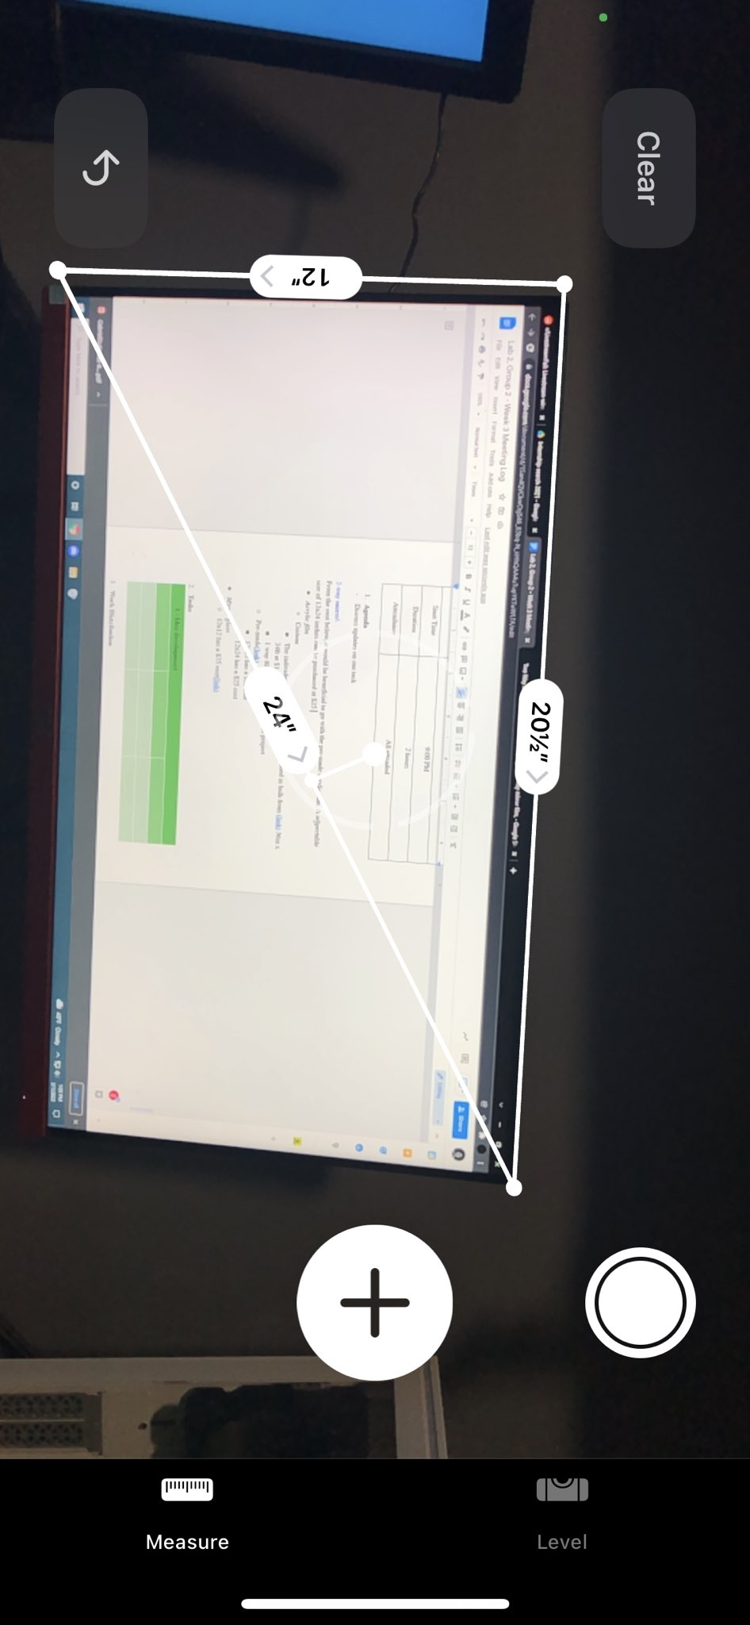

* *Acrylic film*
  + Custom
    - The individual film would have to be purchased in bulk from [(link)](https://www.twowaymirrors.com/two-way-mirror-film/) 36in x 24ft at $162.11
    - 1 way film will not work for this project
  + Pre-made[(link)](https://www.amazon.com/0-04-Acrylic-See-Through-Mirror-Transparent/dp/B01CZ35XWY?th=1)
    - 12x12 has a $15 cost
    - 12x24 has a $25 cost
* *Mirror glass*
  + 12x12 has a $75 cost[(link)](https://www.amazon.com/Two-Way-Glass-Mirror-Surveillance/dp/B07173L96J/ref=sr_1_8?crid=2ICHO07PJB30T&keywords=two+way+mirror+glass&qid=1643649193&sprefix=two+way+mirror+%2Caps%2C78&sr=8-8)

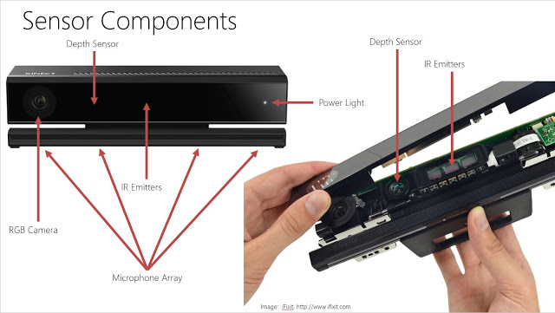

XBox One Kinect

-Refurbished ($84.99)

-Used ($49.99)

-Adapter($10.99)

The best option for us here would be moving forward with a used model. There’s no reason to acquire a new or refurbished model and it would save us a substantial amount of the budget.

The kinect encompasses a few of the necessary components that would be needed to move forward with the smart mirror. We can even remove it from the XBox housing and take the internals and place them wherever we would like on the mirror.

-IR Emitters

-Help with detection in low light situations

-Depth Sensor

-Could be useful for the wakening function if you step close enough

-RGB Camera

-General use in detection and possibly motion controls

AirBar

-Price

-Depends on the display size we would like.

-15.6” ($79.41)

-Relatively compact and can be up to 15.6”

-Plugs in via USB

Touch Frame

-Price

-Depends on the size of the display that we are using. Relatively expensive

-Functionality

-Plugs into PC or Raspberry Pi through USB

AdaFruit Touchscreen Overlays

-Probably the cheapest option. Starting at $5.

Voice Integration

I have added the files on my GitHub will enable us to install Alexa and Google assistant on Raspbian through the git repository:

git clone https://https://github.com/AlanP13/SmartMirrorPi

Running the scripts and rebooting the Pi completes the install. After running the command to boot the repository on start-up, Alexa and Google Assistant start running in the background.

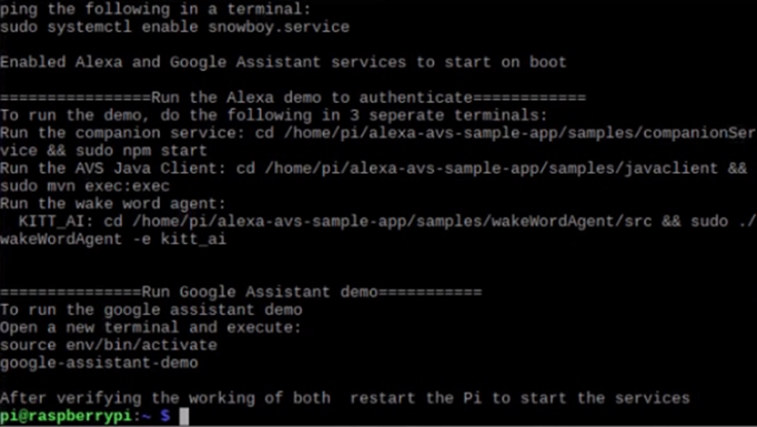

Started researching on the User Interface that will be displayed on the mirror using open source MagicMirror, which in theory should help us add the widgets and place them accordingly. For synchronization of the LEDs for creating ambient effects while running various applications such as Spotify, Youtube, etc. It can be done using Hyperion.

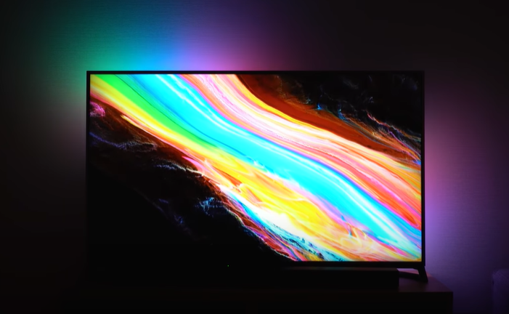 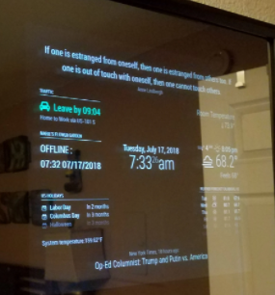

1. **Tasks**

| **1 - Idea development** | | |
| --- | --- | --- |
| **Task** | **Assigned to** | **Due Date** |
| Self-inventory check | Everyone | 2/5 |
| Ask TA about the materials available | Team | 2/3 |
| Look more into hand tracking Gesture Control With Raspberry Pi | Fabian + Gabriel | 2/10 |
| Work on User Interface and light configurations | Alan | 2/10 |

1. **Work Distribution**

| **Alan Palayil** | Start working on the research for Magic Mirror and Hyperion. Similar sources on setting up a minimalistic Layout and App integrations. |
| --- | --- |
| **Fabian Garcia** | Gather materials that are readily available to us for use and begin acquiring the remainder of the materials. Look into hand gesture integration. |
| **Gabriel Gutierrez** | For the meeting: Looked more into the display  Order a personal Raspberry Pi to begin testing and also look for items that can be useful for us. |

1. **Progress and Milestones**

* Alexa and Google Assistant are running in the background on Alan’s Raspberry PI

1. **Next Steps**

To proceed further with the Smart Mirror, we need to discuss what monitors are available to us through IIT. Otherwise, we must acquire a monitor ourselves that will be the base for the smart mirror profile. We have also begun gathering the Raspberry Pi and looking further into computer vision, more specifically, recognition of gestures.

We will meet on 02/05/2022 at 12pm.